Type The Title of Your Paper (Malay/English)

*Capitalise the first letter and italicise all words* *(for English title if your paper is in Malay)*

First Author1, Second Author2*,Third Author3

*1First affiliation, Faculty, University*

*2Second affiliation Faculty, University*

*3Third affiliation Faculty, University*

*Corresponding email

*Received Date:*

*Accepted Date:*

*Published Date:*

***ABSTRACT (“Arial”, Size 11)***

The abstract should summarise the context, content, and conclusions of the paper in less than 250 words. It should not contain any reference citations or displayed equations. Typeset the abstract in 11 pt Arial. Papers may be written in either English or Bahasa Melayu (Malay).

*Keywords*: provide five keywords; provide five keywords; provide five keywords; provide five keywords; provide five keywords

(* If the manuscript is written in Bahasa Melayu, provide the abstract in English and place it below the Malay version)

Insert your heading here (do not copy and paste)

The paragraphs continue from here and are only separated by headings, subheadings, images and formulae. The section headings are bold and Arial, 11 pt. Here are further instructions for authors—no indent for the first paragraph in headings and subheadings.

Structure of MS Word Formatting

Files should be in MS Word format only and should be formatted for direct printing, with left justification for subheadings. Please limit your submission to a maximum of 15 typed pages. Figures and tables should be embedded and not supplied separately.

Please ensure that you use as many regular fonts as possible in your documents. Special fonts, such as fonts used in the Far East (Japanese, Chinese, Korean, etc.), may cause problems during processing. To avoid unnecessary errors, you are strongly advised to use the ‘spellchecker’ function of MS Word.

Follow this order when typing manuscripts: **Title, Authors, Affiliations, Abstract, Keywords, Main text (including figures and tables), Conclusions, Acknowledgements, References, Appendix**. Collate acknowledgements in a separate section at the end of the article and do not include them on the title page, as a footnote to the title or otherwise.

Bulleted lists may be included and should look like this:

1. First point
2. Second point
3. And so on

Ensure that you return to the ‘Main Text’ style, the style that you will mainly be using for large blocks of text, when you have completed your bulleted list.

Please do not alter the formatting and style layouts which have been set up in this template document. As indicated in the template, papers should be prepared in single-column format. Do not number pages on the front, as page numbers will be added separately for the preprints and the Proceedings. Leave a clear line between paragraphs. All the required style templates are provided in this document with the appropriate name supplied.

Tables

All tables should be numbered with Arabic numerals. Headings should be placed above tables and aligned to the centre. Use single space between the caption and the table. Only horizontal lines should be used within a table to distinguish the column headings from the body of the table and immediately above and below the table. Tables must be embedded into the text and not supplied separately. Below is an example which authors may find helpful.

Table 1. An example of a table (Font = 9, Arial, single spacing, do not colour and bold the table)

|  |  |  |
| --- | --- | --- |
| An example of a column heading | Column A (*t*) | Column B (*T*) |
| And an entry | 1 | 2 |
| And another entry | 3 | 4 |
| And another entry | 5 | 6 |

Construction of references

References should be listed at the end of the paper, arranged first alphabetically and then, if necessary, further sorted chronologically. More than one reference from the same author(s) in the same year must be identified by the letters “a”, “b”, “c”, etc., placed after the year of publication. Some examples of how your references should be listed are given at the end of this template in the ‘**REFERENCES**’ section, which will allow you to assemble your reference list according to the correct format and font size.

Section headings

Main section headings should be left justified, bold and use a capital letter starting with the **INTRODUCTION**. Sub-section headings should be in the first letter capitalised and lower-case letters, bold, and left justified.

General guidelines for the preparation of your text

Avoid hyphenation at the end of a line. Symbols denoting vectors and matrices should be indicated in bold type. Scalar variable names should generally be expressed using italics. Weights and measures should be expressed in SI units. Please title your files in the following order: first author's name.docx.

Footnotes

Footnotes should be avoided if possible. Necessary footnotes should be denoted in the text by consecutive superscript letters. The footnotes should be typed single-spaced, and in a smaller type size (9pt), at the foot of the page on which they are mentioned and separated from the main text by a short line extending at the foot of the column. The ‘footnote’ style is available in this template for the text of the footnote.

Referencing and citation style

The manuscript’s references and citations should be written using the APA 7th edition style. In terms of the in-text citation style, APA uses the author's last name and the year of publication, for example: (Field, 2005); (Field & Thomas, 2014). If there are three or more authors, cite only the surname of the first author followed by “et al.” and the year, for example: (Field et al., 2017). For direct quotations, include the page number as well, for example: (Field, 2005, p. 14). More than one reference from the same author(s) in the same year must be identified by the letters “a”, “b”, “c”, etc., placed after the year of publication. Please ensure that every reference cited in the text is also present in the reference list (and vice versa). The number of references should exceed 20, with at least **40% from the last 5 years**. References should be listed in alphabetical order.

The sample of references is available on page 5. Please refer to the following website for further details on APA 7th edition referencing style: https://libraryguides.vu.edu.au/apa-referencing

Author Artwork

All figures should be numbered with Arabic numerals (1,2,...n). All photographs, schemas, graphs and diagrams are to be referred to as figures. Line drawings should be good-quality scans or accurate electronic output. Low-quality scans are not acceptable. Figures must be both embedded into the text, and all images should meet the minimum requirement of 500 x 500 pixels. Lettering and symbols should be clearly defined either in the caption or in a legend provided as part of the figure. Figures should be placed at the top or bottom of a page wherever possible, as close as possible to the first reference to them in the paper.

Diagrams

Diagrams can take the form of a framework, process flow chart, or any other visual aid intended to support the written text. Any diagrams built using Microsoft Word or Microsoft PowerPoint’s SmartArt Graphic Tool must be embedded as editable or vector-based objects (instead of image objects). Diagrams attached using bitmap-based images (JPEG, PNG, and other formats) need to be in high resolution (at least 300 pixels per inch).

Texts embedded in diagrams

The font used for labels or indicators inside the diagram should be formatted as Arial with a font size of 9. It must not be bold, italicised or underlined.

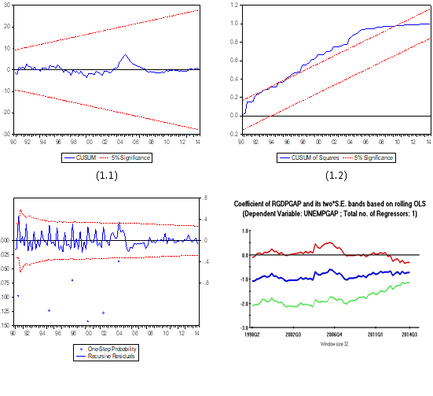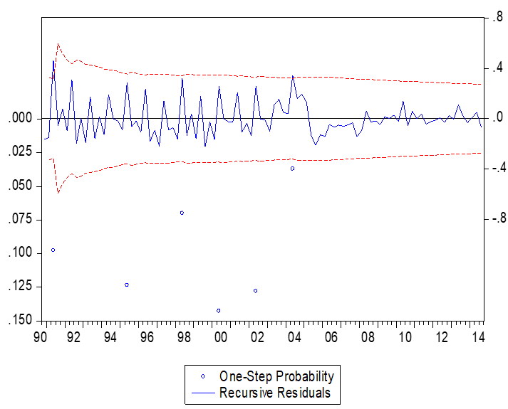

Figure 1. (left) This figure is blurry, which is unacceptable; (right) this figure has a higher resolution. However, the labels are not formatted using Arial font. (Font = 9, Arial, single spacing)

**Socio-economic factors**

Savings to income ratio

Financial status

Income adequacy

**Financial literacy**

**Financial behaviour**

**Debt burden**

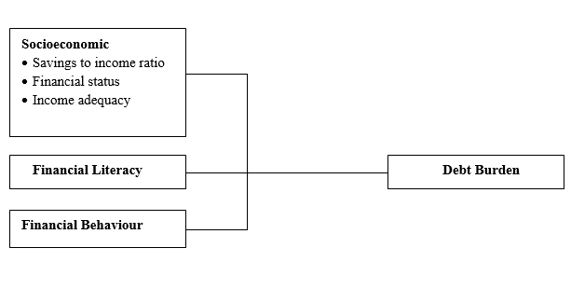

Figure 2. (left) This framework is a non-editable diagram, appears blurry and hence, is unacceptable;   
(right) This framework is built using MS Word illustration tools, has higher resolution and is acceptable.

Please use the ‘drawing canvas tool’ in MS Word before inserting any images or diagrams into the document. When constructing a conceptual or theoretical framework, please use editable or vector-based diagrams. Draw diagrams using MS Word’s Smart Art Graphic Tool (textboxes, labels, arrows, legends, etc.) rather than embedding non-editable image objects. Ensure that all figures have a good resolution (minimum 300 dpi) and are not fuzzy or blurry.

Captions

The figure number and caption should be typed below the illustration in 9-point font and left-justified. Artwork has no text along the side of it in the main body of the text. However, if two images fit next to each other, they can be placed side by side to save space, as shown in Figure 1. They must be numbered consecutively, all figures and all tables respectively.

Equations and Formulas

Equations and formulae should be typed and numbered consecutively with Arabic numerals in parentheses on the right-hand side of the page (if referred to explicitly in the text). They should also be separated from the surrounding text by one space. If you choose to use the Equation Editor, please ensure that the manuscript is saved using the .docx format (rather than .doc), and Compatibility Mode is turned off.

|  |  |  |
| --- | --- | --- |
|  | Rt = K EP = 93.02 (±9.62) – 13.45 | (1) |

ACKNOWLEDGMENTS (US) OR ACKNOWLEDGEMENTS (UK)

This section is compulsory. The following is an example of an acknowledgement statement:

The authors would like to acknowledge the support of Universiti Teknologi Mara (UiTM), Cawangan Negeri Sembilan, Kampus Kuala Pilah and Faculty of Applied Sciences, Universiti Teknologi MARA, Shah Alam, Selangor, Malaysia, for providing the facilities and financial support for this research.

CONFLICT OF INTERESTS

This section is compulsory. The following is an example of a conflict-of-interest statement:

The authors agree that this research was conducted in the absence of any self-benefits, commercial or financial conflicts and declare the absence of conflicting interests with the funders.

AUTHORS’ CONTRIBUTIONS

Each author's contribution must be stated clearly, reflecting their specific contributions to the body of the work and the manuscript. Authors can refer to [CRediT](http://credit.niso.org/) (Contribution Roles Taxonomy) for detailed information about individual contributions to the work. For example:

Jaya Subramaniam conducted the research, wrote, and revised the article. Rahmah Hassan conceptualised the central research idea and provided the theoretical framework. Rahmah Hassan and Chong Ju Lian designed the research and supervised its progress; Rahmah Hassan led the review, revisions, and approved the article for submission.

REFERENCES (APA 7TH ED.)

Typeset reference list in 10pt Arial with single spacing. **Where a DOI is available, it must be included at the end of the reference.** Please refer to the following website for further details on APA 7th edition referencing style: https://libraryguides.vu.edu.au/apa-referencing

Below are examples of entries for journal articles, newspapers, reports, webpages and books.

Aspy, D. J., and Proeve, M. (2017). Mindfulness and loving-kindness meditation: Effects on connectedness to humanity and to the natural world. Psychological Reports, 120(1), 102-117. https://doi.org/10.1177/0033294116685867

Australian Institute of Health and Welfare. (2018). Family, domestic and sexual violence in Australia 2018. https://www.aihw.gov.au/getmedia/d1a8d479-a39a-48c1-bbe2-4b27c7a321e0/aihw-fdv- 02.pdf.aspx?inline=true

Haile, L., Gallagher, M., & Robertson, R. J. (2015). Perceived exertion laboratory manual: From standard practice to contemporary application. Springer. https://doi.org/10.1007/978-1-4939-1917-8

Hasler, E. (2018). The built environment. Liverpool University Press.

Johnson, A. (2018, May 24). “It doesn’t need to be this way”: The promise of specialised early intervention in psychosis services. IEPA. https://iepa.org.au/network-news/it-doesnt-need-to-be-this-way-the-promise- of-specialised-early-intervention-in-psychosis-services/

Moran, A., & Toner, J. (2017). A critical introduction to sport psychology (3rd ed.). Routledge.

Ruxton, C. (2016). Tea: Hydration and other health benefits. Primary Health Care, 26(8), 34-42. https://doi.org/10.7748/phc.2016.e1162

Spring, A. & Earl, C. (2018, May 22). ‘Just not blond’: How the diversity push is failing Australian fashion. The Guardian: Australia Edition. https://www.theguardian.com/fashion/2018/may/22/just-not-blonde-how-the-diversity-push-is-failing-australian-fashion

Wilmott, C., Fraser, E., & Lammes, S.  (2018). ‘I am he. I am he. Siri rules': Work and play with the Apple Watch, *European Journal of Cultural Studies,* *21*(1), 78-95.  https://doi.org/10.1177/1367549417705605

**ABOUT THE AUTHORS**

Please submit another separate file by naming it “Author Information”. Avoid revealing the identity and information of the authors in the manuscript (which should be anonymous). Provide the following information in a separate file.

*Author 1 (Full Name, without Titles/Designation)*, Please summarise the academic background and details of the author and contact information (an e-mail address is compulsory). The authors’ biographical information will be displayed after the Reference List. The maximum number of words is 100.

*Author Full Name 2 (Full Name, without Titles/Designation)*, Please summarise the academic background and details of the author and contact information (an e-mail address is compulsory). The authors’ biographical information will be displayed after the Reference List. The maximum number of words is 100.

*EXAMPLE:*

*Danial Rashid, PhD*, is an Associate Professor in the Department of Management and Finance at the University of Nusantara. His main research activity is in organisational innovation and organisational learning. He has published widely on these subjects in publications such as the *International Journal of HRM, Industrial Marketing Management,* *Journal of Business Research*, *International Journal of Information Management and Management Decision*. He can be reached through his email at [danialrashid@nusantarauni.edu](mailto:danialrashid@nusantarauni.edu).my.